Analyzing the Impact of Economic Factors on Housing Prices in the United States

Stanley Occean, Jonah Liautaud
Pace University, Seidenberg School of CSIS
So51517n@pace.edu, jl48590n@pace.edu

Abstract— Economic conditions vary across U.S. states, and those differences can shape housing prices, migration patterns, and overall affordability, which are important for policymakers and researchers. This study examines the relationship between housing prices and multiple economic factors, including income growth, population change, migration, unemployment rates, and cost-of-living differences, across all 50 states in the United States from 2020 to 2024. To do this, data from the Bureau of Labor Statistics, the U.S. Census Bureau, the Bureau of Economic Analysis, the Federal Housing Finance Agency, and the Internal Revenue Service were merged into a unified state-year dataset. After the data was cleaned and organized, exploratory data analysis was used to identify patterns, correlations, and trends across states and over time. Multiple linear regression was then applied to examine how these variables are associated with housing prices when considered together in the same model. The results suggest that income growth is positively associated with housing prices, whereas unemployment is negatively associated with housing prices. Cost-of-living differences, measured through Regional Price Parities, appear to have one of the strongest positive associations with housing prices in the dataset. These findings suggest that housing prices are shaped more by multiple economic factors rather than any single factor.

Index Terms— housing prices, migration, unemployment, income growth, cost of living, Regional Price Parities, panel data, multiple linear regression, state-level economic analysis.

I. INTRODUCTION
Housing prices matter because they affect more than just the cost of buying a home. They also shape affordability, migration decisions, financial stability, and the overall economic pressure people feel in different parts of America. When housing prices rise, it becomes harder for many people to afford to live in certain areas, and that can influence where they choose to move, work, or stay. As a result, studying housing prices is important for understanding not just the housing market itself but also broader economic conditions across the United States.
However, economic conditions vary across states. Some states experience stronger income growth, lower unemployment, or larger population increases, while others face the opposite, such as slower growth, higher unemployment, or higher overall living costs. These differences can affect housing demand in different ways, so it’s imperative to have that understanding when collecting data. A state with stronger job growth and rising incomes may see more pressure on housing prices, while a state with weaker economic conditions may not experience the same kind of price increases. Looking at these differences across states makes it easier to see why housing prices do not move the same way everywhere. Understanding these differences is important when accounting for potential bias in the analysis.
This study focuses on several variables that may help explain those differences: unemployment rates, income growth, population change, migration patterns, and cost-of-living differences. Housing prices are measured using the Federal Housing Finance Agency House Price Index, while Regional Price Parities represent cost-of-living differences. Together, these variables provide a broader picture of the economic and demographic factors that may be associated with housing price patterns across states.
The core question of this research is: How are unemployment, income growth, population change, migration, and cost-of-living differences associated with housing prices in U.S. states between 2020 and 2024? This study also seeks to determine which of these variables shows the strongest relationship with housing prices, reinforcing the idea that a combined, rather than isolated, approach best explains housing price variation.
To answer these questions, this project combines data from the Bureau of Labor Statistics, the U.S. Census Bureau, the Bureau of Economic Analysis, the Federal Housing Finance Agency, and the Internal Revenue Service into a unified state-year dataset. Because the study period begins in 2020, the analysis also takes place during a period of unusual housing market conditions in the United States. After cleaning and merging the data, exploratory data analysis is used to identify trends and relationships across states and over time. The study then applies multiple linear regression to examine how these economic factors jointly relate to housing prices. This approach supports the project’s main argument that housing prices are better understood through a multivariable framework rather than a one-variable explanation.
II. LITERATURE REVIEW
Prior research shows that housing prices are influenced by a mix of economic and demographic factors rather than one single variable. Glaeser, Gyourko, and Saks argue that housing prices rise because of broader housing market pressures and structural constraints, while Duca, Muellbauer, and Murphy show that house price cycles reflect wider economic, demographic, and market conditions [5], [11]. These studies are important for this project because they support the idea that housing prices should be studied through a multivariable framework instead of being explained by only one factor at a time.
Other research suggests that migration, labor market conditions, and affordability are also important parts of the housing story. Prior work shows that higher income can increase purchasing power and housing demand, while weaker labor conditions can reduce income stability and lower housing demand. Molloy, Smith, and Wozniak show that internal migration in the United States is closely tied to broader economic conditions, which helps explain why migration belongs in this project even if its role may differ across states [8]. Cost-of-living differences also matter because states with higher overall price levels often face higher housing costs, which is why Regional Price Parities are useful in this study as a measure of cost of living.
Another important factor in this project is the COVID-19 period itself, since the dataset begins in 2020. Liu and Su found that the pandemic changed housing demand in the United States by reducing demand for density, which suggests that housing preferences shifted during this time [21]. Mondragon and Wieland also argue that remote work played a major role in the rise of housing prices, showing that the shift to remote work explains over half of the increase in U.S. real house prices from 2019 to 2023 [22]. These studies matter for this project because they suggest that part of the housing price growth observed from 2020 onward may reflect pandemic-related changes in where people wanted to live, how much housing space they wanted, and how remote work changed housing demand across regions.
Taken together, the literature suggests that housing prices are influenced by income, labor market conditions, migration, and broader cost-of-living differences. However, these factors are often discussed separately. This project adds to that literature by combining unemployment, income growth, population, migration, housing prices, and Regional Price Parities into one 50-state panel dataset covering 2020 to 2024. By doing that, the study examines how these variables relate to housing prices when they are analyzed together during a period that also includes the unusual housing conditions associated with COVID-19.
III. METHODOLOGY
This study uses a quantitative state-year panel design. The final sample includes only the 50 U.S. states and removes data on the District of Columbia from the merged analysis. The core panel covers 2020 through 2024 and includes the following variables: FHFA house price index, BLS unemployment rate, BEA-based income change, Census population, and BEA Regional Price Parities. Migration is added using IRS state-to-state inflow and outflow data for the 2020–2021, 2021–2022, and 2022–2023 flow years. In the merged panel, these files are used to create migration observations for 2021, 2022, and 2023. As a result, the full-panel baseline regression uses unemployment rate, income change, population, and RPP, while a second regression adds net migration only for the reduced 2021 to 2023 subset.
The first step in the method is data cleaning. Each source file was standardized so the records could be merged by state and year. State names were aligned across files, the United States total row was removed where needed, and the District of Columbia was removed to keep the sample at 50 states consistent. The RPP file was reshaped from wide format to long format so that each row holds one state, one year, and one RPP value. The migration files were aggregated to the state level and used to create inflow, outflow, and net migration measures.
The merged dataset is organized as a panel. For the full 2020 to 2024 panel, there are 250 state-year observations. For models or charts that use migration, the usable sample is smaller because IRS migration data are only available for the 2020–2021 through 2022–2023 flow years. In the merged panel, that means migration can only be analyzed for 2021 through 2023. That leaves 150 observations for the migration subset. This matters because any statement about migration must be limited to the years observed in the IRS files.
Exploratory data analysis was used first. Time-series plots were used to examine average changes over time; scatterplots were used to compare housing prices with RPP and migration; and a correlation heatmap was used to show the strength and direction of pairwise relationships. The cleaned 50-state results show that higher-RPP states tend to have higher housing price index values, suggesting that the cost of living and housing prices are closely linked, which is another reason RPP is included in the baseline regression rather than treated solely as a descriptive variable. The results also show that higher unemployment tends to line up with lower housing price index values. Income change has a positive relationship with housing prices, but not as strong as RPP. Population by itself is much weaker in the simple correlation results. Migration was included as a factor for the available years, but its relationship with housing prices is weaker than that of RPP, income change, and unemployment.
To move beyond descriptive analysis, the project applies a multiple linear regression model. The main model for the project remains multiple linear regression. A baseline version of the model can be written as:
Housing Price Index = β₀ + β₁(Unemployment Rate) + β₂(Income Change) + β₃(Population) + β₄(RPP) + ε.
This version adds RPP to the earlier draft because the cost of living is now in the cleaned merged file and clearly belongs in the model. A second version can include net migration for the reduced 2021 to 2023 subset:
Housing Price Index = β₀ + β₁(Unemployment Rate) + β₂(Income Change) + β₃(Population) + β₄(RPP) + β₅(Net Migration) + ε.
These models are used to estimate how each variable relates to housing prices while the others are held constant. Regression was selected because no single variable alone explains housing prices, and the goal of the project is to examine how several economic factors work together in the same model. Adding RPP strengthens the baseline model because the cost of living is one of the clearest parts of the broader housing story, and the cleaned results show that higher-RPP states also tend to have higher housing price index values. The second model is more limited because migration is only available from the 2020–2021 through 2022–2023 flow years, which in the merged panel corresponds to the reduced 2021 to 2023 subset.
Together, these models support the main purpose of the project, which is to understand housing prices through a broader economic lens rather than a one-variable explanation.
In addition to multiple linear regression, Random Forest Regression was used as a comparison model. While multiple linear regression provides a baseline for examining the direction of relationships among variables, Random Forest can capture nonlinear patterns and interactions that may not be fully reflected in a linear model. Both models used unemployment rate, income change, population, and Regional Price Parities as predictors, with housing price index as the dependent variable. A second comparison used the reduced 2021–2023 subset and added net migration. Model performance was evaluated using an 80/20 train-test split and compared using RMSE, MAE, and R².
Comparing these models helps determine whether a more flexible machine learning method improves predictive performance beyond the traditional regression approach. There are also some important limits to this method. The project overview notes that some datasets may have missing values, inconsistent formats, or differences in reporting periods. It also highlights the challenge of distinguishing correlations from causation. That is an important point in this project because even if two variables move together, that does not automatically mean one is causing the other. Another limit is that migration does not cover the full 2020 to 2024 period, so any model that includes net migration must be limited to the reduced 2021 to 2023 subset and interpreted more carefully than the full-panel baseline model. Because of that, the analysis is meant to identify patterns and relationships, not to make overly strong causal claims. The model assumes linear relationships between variables and does not account for unobserved state-level effects. Future work could incorporate fixed effects models to better control for these differences.
This study has several limitations that should be kept in mind when interpreting the results. First, migration data is only available for the 2020–2021, 2021–2022, and 2022–2023 flow years, which means migration cannot be tested across the full 2020 to 2024 panel and is limited to the 2021 to 2023 portion of the merged dataset. Second, the project uses state-level data, so differences within states are not captured. Housing market patterns may look different at the city, county, or metro level. Third, the models in this study identify statistical relationships rather than causal effects. Finally, because the sample period begins in 2020, some of the observed housing price patterns may reflect unusual pandemic-era conditions rather than only longer-run housing market behavior. These limits do not remove the value of the results, but they do mean the findings should be interpreted with appropriate caution.

Overall, the methodology is designed to support a multivariable analysis of housing prices and economic conditions across U.S. states. By combining multiple datasets into a single panel structure, conducting exploratory analysis, and estimating a regression model, the project creates a framework for assessing how unemployment, income, population, migration, and cost-of-living conditions relate to housing market outcomes over time and across places.

IV. RESULTS AND ANALYSIS

The results show that housing prices are associated with several major economic indicators at the state level across the United States from 2020 to 2024. Using the merged 50-state dataset, this study first examined correlations and multiple linear regression results, then compared these findings with a Random Forest Regression model to evaluate whether a machine learning approach could improve predictive performance.

The correlation and regression results tell a consistent story. Regional Price Parities (RPP) remain the strongest associated factor in the dataset, with a correlation coefficient of about 0.56 to 0.60 with housing prices. This indicates that states with higher cost-of-living levels generally also have higher housing prices. Income change shows a positive but weaker relationship, while unemployment is negatively associated with housing prices. Population and migration show weaker effects, suggesting that they are not strong standalone explanatory variables in this dataset. These results reflect statistical associations and do not imply causation between the variables.
The regression results support the same general pattern shown in the correlations and visualizations. In the baseline model covering 2020 to 2024, Regional Price Parities remain one of the strongest explanatory variables, which suggests that the cost of living is closely tied to housing prices even when other factors are considered at the same time. Income change continues to show a positive relationship with housing prices, while unemployment remains negatively related. Population is weaker as a standalone variable, which is consistent with the earlier correlation analysis.
The reduced migration model for 2021 to 2023 provides a more limited test because the number of observations is smaller, and migration data is only available for that subset. In that model, net migration does not appear to be as strong as RPP, income change, or unemployment. This suggests that migration may matter more indirectly, or that its effect is harder to isolate at the state-year level in the current dataset. Taken together, the regression models support the broader conclusion that housing prices are best explained by multiple economic conditions rather than a single variable.
To compare the traditional regression approach with a machine learning method, Random Forest Regression was applied to the same data used in the baseline regression model. On the full 2020–2024 dataset using unemployment rate, income change, population, and RPP, Random Forest performed better than multiple linear regression. Random Forest produced lower RMSE and MAE values and a higher R², indicating more accurate predictions and a better overall fit on the test data. However, when net migration was added using the reduced 2021–2023 subset, multiple linear regression performed better than Random Forest. This suggests that the machine learning model improved predictions on the larger baseline dataset but did not consistently outperform the linear model as the sample size decreased.

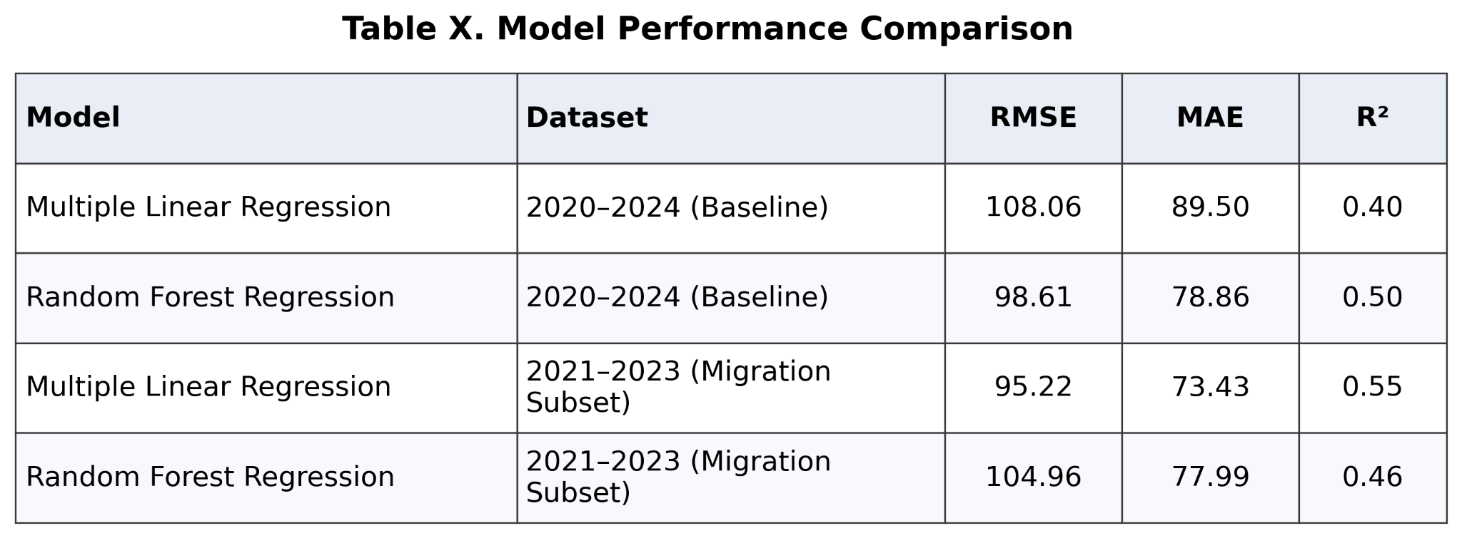
Table X. Model Performance Comparison Using RMSE, MAE, and R². The detailed performance metrics for both models are presented in Table X. Random Forest outperformed multiple linear models.
The unemployment rate is negatively associated with housing prices. Higher unemployment rates correspond to lower prices, as shown in Fig. 2. This implies that labor market downturns decrease housing demand and, hence, prices.

Income change shows a positive relationship with housing prices, though it is weaker than that of RPP. In general, states with stronger income growth tend to have higher housing price index values. Fig. 3, with its upward trend, gives a positive link between income growth and housing price index (HPI). Migration appears to be the weakest predictor of housing prices among the variables considered in our study. Despite the general perception of population movement as a leading cause of the rise in housing demand, our findings indicate a very limited effect over the period considered. Our dataset includes IRS migration flow data for 2020–2021, 2021–2022, and 2022–2023, which are used in the merged panel for 2021 to 2023. This still makes migration more limited than the full 2020 to 2024 panel and makes it harder to analyze longer-run migration trends.

Furthermore, the time-series analysis indicates that housing prices have been rising at an average pace from 2020 to 2024. Referring to Fig. 4, the average Housing Price Index increased from about 372 to 544. This reflects a strong upward trend in housing prices across states during the study period.

Overall, the results suggest that housing prices are best explained by a combination of economic factors rather than any single variable. Cost of living, measured through RPP, stands out as the strongest associated factor, while unemployment and income provide additional explanatory power. The comparison between multiple linear regression and Random Forest Regression further suggests that model performance depends on both the size and structure of the data, with Random Forest improving predictions on the full dataset but not on the smaller migration subset.

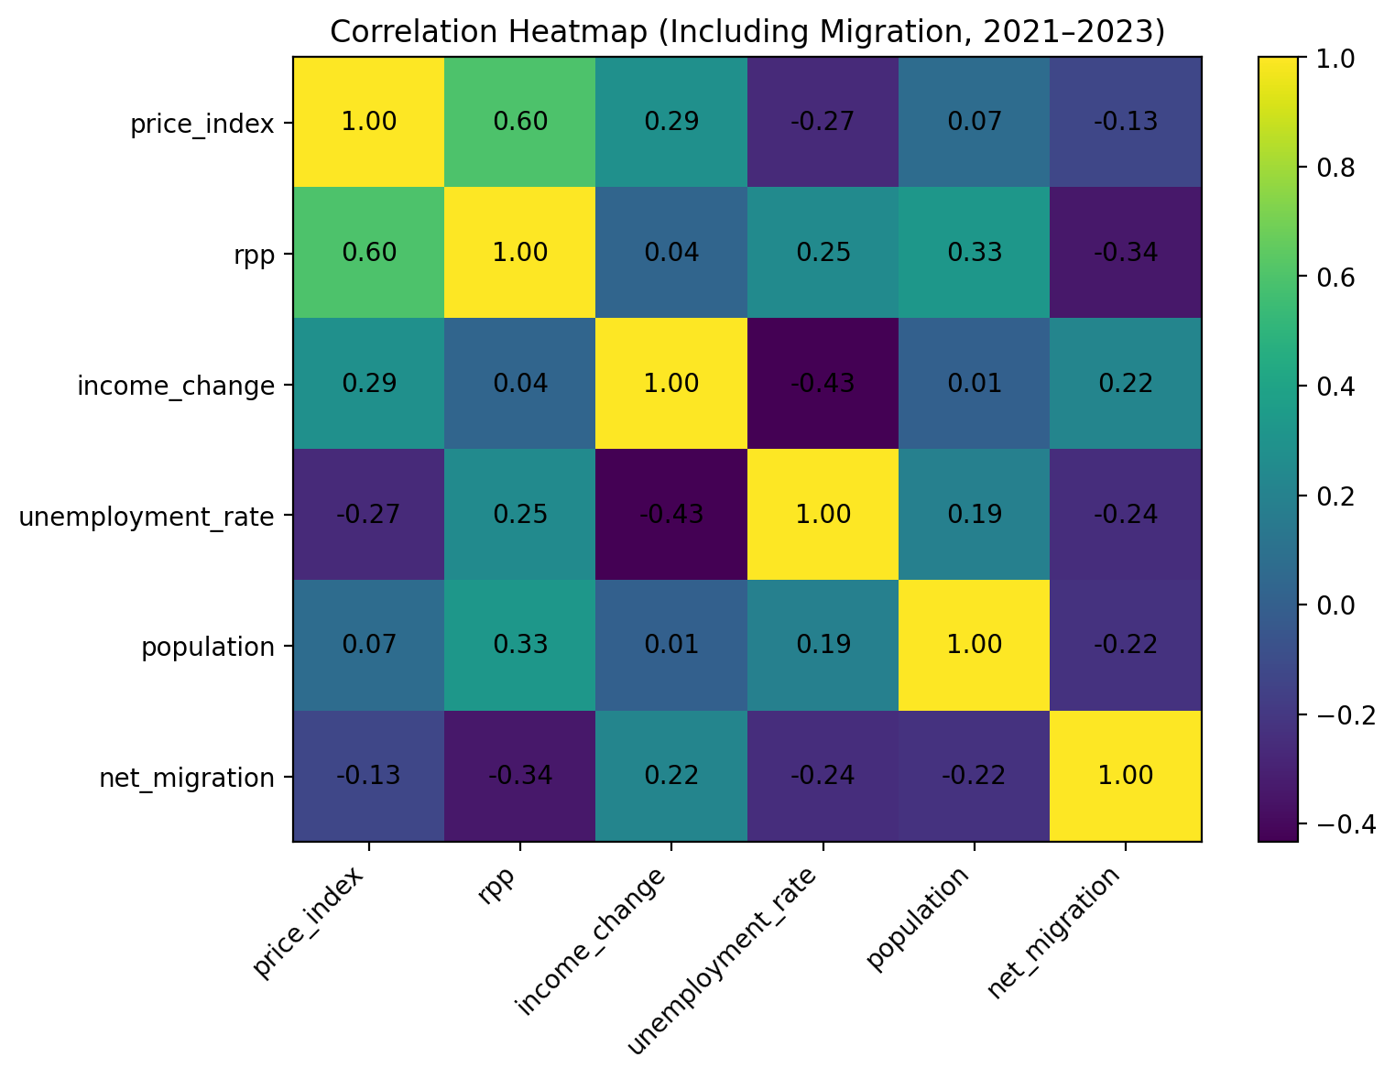

Fig. 1. Correlation heatmap of housing price index and key economic variables, including RPP, income change, unemployment rate, population, and net migration (2021–2023). The results show that RPP has the strongest positive relationship with housing prices, while the unemployment rate exhibits a negative correlation.

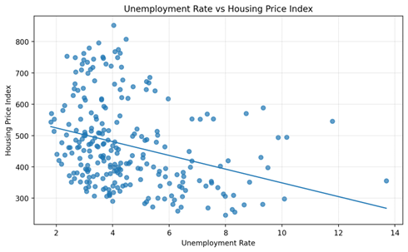

Fig. 2. Scatter plot of unemployment rate versus housing price index. The downward trend line indicates a negative relationship, suggesting that higher unemployment rates are associated with lower housing prices.

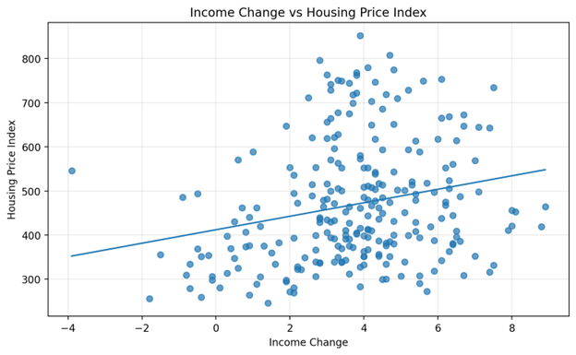

Fig. 3. Scatter plot of income changes versus housing price index. The upward trend line shows a positive relationship, indicating that higher housing prices are associated with higher income, even if the effect is moderate.

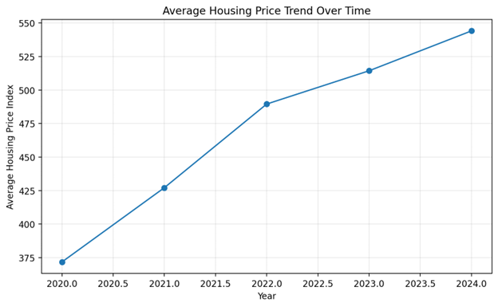

Fig. 4. Trend of average housing price index from 2020 to 2024. The steady increase reflects strong growth in housing prices across U.S. states during this period.

To further illustrate the geographic distribution of housing prices, Fig. 5 presents a choropleth map of the housing price index across U.S. states.
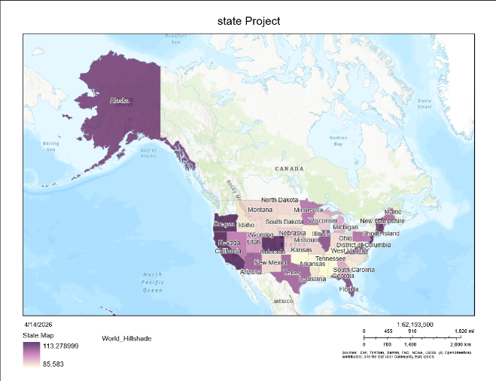

Fig. 5. Choropleth map of housing price index across U.S. states. Darker shades indicate higher housing price levels, highlighting regional disparities, with higher concentrations in coastal and economically strong states.

V. DISCUSSION
The results support the main idea from the literature review that housing prices are shaped by multiple factors rather than one single variable [5], [11]. In this project, the cost of living, measured through Regional Price Parities, appears to be the clearest signal. That suggests housing prices are not just moving because of local demand in a narrow sense. They seem to be tied to a broader state-level economic environment where places with higher overall prices also tend to have higher housing prices. This helps explain why RPP remained stronger than population and migration in the data.
The results also partly support the expectation that income and labor market conditions matter for housing prices. Income change shows a positive relationship with housing prices, while unemployment shows a negative one. This fits the prediction from prior research that stronger economic conditions should be associated with stronger housing markets. At the same time, the results suggest that income growth alone does not fully explain housing price differences, since RPP still appears more important in the overall pattern.
One interesting point is that migration was weaker than expected. Based on the literature, migration should matter because population movement can affect housing demand [8]. However, in this dataset, it was not one of the strongest standalone factors. One way to interpret that is that migration may be responding to broader economic conditions that are already being captured more directly by variables like RPP, income, and unemployment, rather than acting as the main driver by itself. It is also important to remember that migration is based on IRS flow-year files covering 2020–2021 through 2022–2023, which in the merged panel means it is only measured for the reduced 2021 to 2023 subset. Because of that, its role is more limited in this study than the other variables.
The time period of this project also matters. Because the sample begins in 2020, the results should be interpreted in the context of the COVID-19 period. Prior research suggests that the pandemic changed housing demand by reducing demand for density and increasing the importance of remote work [21], [22]. That makes this relevant to the project because part of the rise in housing prices during the sample period may reflect pandemic-related shifts in where people wanted to live, how much space they wanted, and how remote work changed housing demand across regions. This may also help explain why housing prices rose strongly over time, even when some of the other variables were weaker on their own.
Another implication of these results is that housing affordability cannot be understood by looking at housing prices alone. If the cost of living is more strongly tied to housing prices than population or migration in this dataset, then affordability pressure may be part of a broader regional economic environment rather than just a simple housing shortage story. This helps explain why some states can appear economically strong while still becoming harder to afford. In that sense, the project’s findings line up with the literature by suggesting that housing prices reflect combined market pressures, labor conditions, and price-level differences rather than one single force [5], [11].
Overall, the findings suggest that housing prices in this project are best understood through a multivariable lens. The results line up with the literature review by showing that housing prices reflect the combined effect of cost of living, labor market conditions, and income rather than any one variable by itself. In this dataset, RPP stands out the most, while income and unemployment provide additional support for the broader explanation. That means the project’s original expectation was mostly supported, but it also shows that some variables, especially migration, may be more limited or indirect than they first appear.
VI. CONCLUSION
This research examined how major economic indicators relate to housing prices across U.S. states. The results suggest that housing prices are best understood through a multivariable framework rather than a one-variable explanation. Among the variables in this study, Regional Price Parities emerged as the strongest signal, suggesting that the cost of living is one of the clearest parts of the broader housing story. Income growth and unemployment also contributed to the explanation, while migration appeared more limited in the current dataset because of data coverage and time-period constraints.
The comparison between multiple linear regression and Random Forest Regression also showed that model performance depends on the size and structure of the data. Random Forest performed better on the full dataset, while the linear model remained stronger on the smaller migration subset.
Overall, the study suggests that housing markets reflect several connected economic conditions at once, especially the cost of living, labor market strength, and income patterns. These findings help explain why housing prices differ across states and why they should be interpreted within a broader regional economic context.
Future research can improve upon this study by incorporating additional factors, such as housing stock, interest rates, and the availability of mortgage loans. Getting fresh migration starts post-2023 would add more flavor to understanding the population movement trends. Furthermore, future projects could also compare additional predictive models, such as gradient boosting, with the regression and Random Forest models used in this study to evaluate whether other approaches improve performance.

Gathering data at the city or county level could provide more detail and support the validity of the findings. Finally, using panel data techniques or time-series forecasting methods might not only better reflect the housing market's evolution but also yield firmer results.

VII. REFERENCES

[1] U.S. Census Bureau, “State Population Totals and Components of Change: 2020–2025,” Washington, DC, USA, 2026. [Online]. Available: https://www.census.gov
[2] U.S. Bureau of Labor Statistics, “Local Area Unemployment Statistics (LAUS),” Washington, DC, USA, 2025. [Online]. Available: https://www.bls.gov/lau/
[3] Federal Housing Finance Agency, “FHFA House Price Index Datasets,” Washington, DC, USA, 2025. [Online]. Available: https://www.fhfa.gov
[4] U.S. Bureau of Economic Analysis, “Regional Price Parities by State and Metro Area,” Washington, DC, USA, 2024. [Online]. Available: https://www.bea.gov
[5] E. L. Glaeser, J. Gyourko, and R. E. Saks, “Why Have Housing Prices Gone Up?” *American Economic Review*, vol. 95, no. 2, pp. 329–333, May 2005.
[6] C. I. Jones, “The Facts of Economic Growth,” in *Handbook of Macroeconomics*, vol. 2, J. B. Taylor and H. Uhlig, Eds. Amsterdam, The Netherlands: Elsevier, 2016, pp. 3–69.
[7] J. M. Quigley and S. Raphael, “Regulation and the High Cost of Housing in California,” *American Economic Review*, vol. 95, no. 2, pp. 323–328, May 2005.
[8] R. Molloy, C. L. Smith, and A. Wozniak, “Internal Migration in the United States,” *Journal of Economic Perspectives*, vol. 25, no. 3, pp. 173–196, Summer 2011.
[9] D. H. Autor, D. Dorn, and G. H. Hanson, “The China Shock: Learning from Labor-Market Adjustment to Large Changes in Trade,” *Annual Review of Economics*, vol. 8, pp. 205–240, 2016.
[10] U.S. Bureau of Economic Analysis, “Real Personal Consumption Expenditures by State and Real Personal Income by State and Metropolitan Area,” Washington, DC, USA, 2024. [Online]. Available: https://www.bea.gov
[11] J. V. Duca, J. Muellbauer, and A. Murphy, “What Drives House Price Cycles? International Experience and Policy Issues,” *Journal of Economic Literature*, vol. 59, no. 3, pp. 773–864, 2021.
[12] E. L. Glaeser and J. Gyourko, “Housing Dynamics,” *Annual Review of Economics*, vol. 10, pp. 379–406, 2018.
[13] A. Mian and A. Sufi, “House Prices, Home Equity-Based Borrowing, and the U.S. Household Leverage Crisis,” *American Economic Review*, vol. 101, no. 5, pp. 2132–2156, 2011.
[14] R. J. Shiller, “Long-Term Perspectives on the Current Boom in Home Prices,” *The Economists’ Voice*, vol. 2, no. 4, 2005.
[15] Federal Reserve Bank of St. Louis, “Housing Market Conditions and Economic Indicators,” St. Louis, MO, USA, 2023. [Online]. Available: https://fred.stlouisfed.org
[16] OECD, *Housing Affordability in Cities in the United States*. Paris, France: OECD Publishing, 2021.
[17] National Association of Realtors, “Housing Affordability Index,” Chicago, IL, USA, 2023. [Online]. Available: https://www.nar.realtor
[18] Zillow Research, “U.S. Housing Market Trends and Forecast,” Seattle, WA, USA, 2024. [Online]. Available: https://www.zillow.com/research/
[19] Freddie Mac, “Housing Market Outlook,” McLean, VA, USA, 2024. [Online]. Available: https://www.freddiemac.com
[20] World Bank, *Housing Market and Economic Growth: Global Evidence*. Washington, DC, USA: World Bank, 2022.
[21] S. Liu and Y. Su, “The impact of the COVID-19 pandemic on the demand for density: Evidence from the U.S. housing market,” Economics Letters, vol. 207, 2021.
[22] J. A. Mondragon and J. Wieland, “Housing Demand and Remote Work,” NBER Working Paper No. 30041, 2022. doi: 10.3386/w30041.

